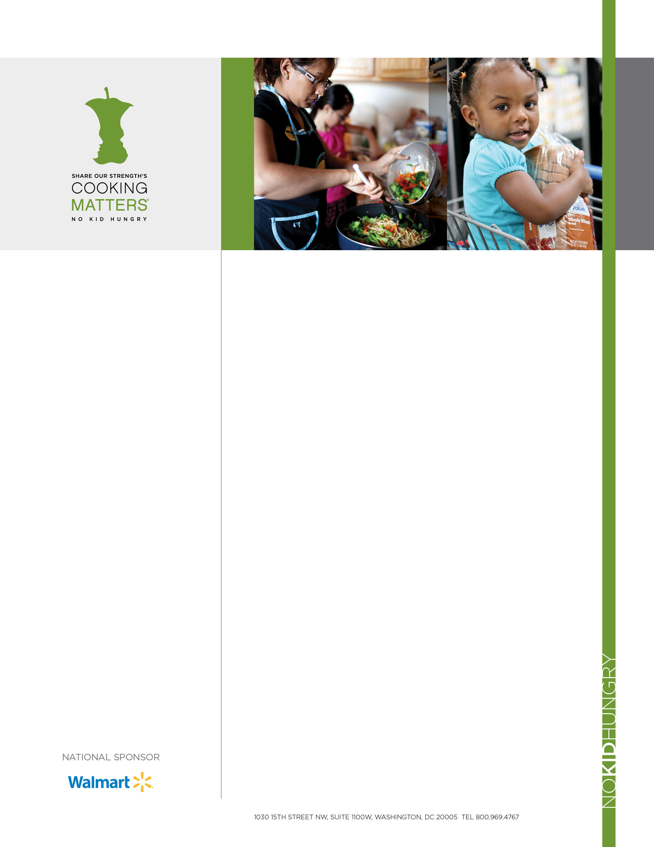­­

CookingMatters.org

SHARE OUR STRENGTH’S   
NO KID HUNGRY CAMPAIGN

No child should grow up hungry in America, but one in five children struggles with hunger. Share Our Strength’s No Kid Hungry campaign is ending childhood hunger by ensuring all children in the U.S. get the healthy food they need, every day.

The No Kid Hungry campaign connects kids in need with effective nutrition programs like school breakfast and summer meals and teaches their families how to cook healthy, affordable meals. We surround children with healthy food where they live, learn and play.

Together, we are making No Kid Hungry a reality in America. To join us, visit **NoKidHungry.org**.

**COOKING MATTERS: BUILDING FOOD SKILLS   
TO END CHILDHOOD HUNGER**

As part of the national No Kid Hungry campaign working to end childhood hunger in America, Cooking Matters empowers low-income families to stretch their food budgets so their children get healthy meals at home. Participants learn to shop smarter, use nutrition information to make healthier choices, and cook delicious, affordable meals. Cooking Matters courses and tours equip families with the skills they need to stretch their food dollars and maximize the benefits they receive through public nutrition programs like SNAP (food stamps) and WIC (Women, Infants and Children).

Founded in 1993, Cooking Matters has served more than 464,000 families across the country. Cooking Matters has been featured by First Lady Michelle Obama’s Let's Move! campaign and recognized by the U.S. Department of Agriculture for excellence in nutrition education. Cooking Matters is nationally sponsored by Walmart.

**HOW IT WORKS**

Cooking Matters serves families across the country through:

* **Hands-On, Six-Week Courses**

Community partners that serve low-income families offer six-week Cooking Matters courses to adults, kids and families. Each course is team-taught by a volunteer chef and nutrition educator and covers meal preparation, grocery shopping, food budgeting and nutrition. Adult and teen participants take home a bag of groceries at the end of each class.

* **Interactive Grocery Store Tours**

Cooking Matters at the Store tours provide families with hands-on education as they shop for food, giving them skills to compare foods for cost and nutrition. Participants learn how to plan and budget for healthy, affordable, and delicious meals for their families.

* **Educational Tools**

Free toolkits, kids’ handouts and recipes are available at **CookingMatters.org** and in the smartphone app, Cooking Matters.



**FOOD SKILLS EDUCATION   
TO MAKE HEALTHY, AFFORDABLE MEALS**  
In the national survey *It’s Dinnertime: A Report on Low-Income Families' Efforts to Plan, Shop for, and Cook Healthy Meals*, No Kid Hungry found that 85% of low-income families rate eating healthy as important, and most families prepare meals at home five nights of the week, but only about half are able to make healthy meals on a regular basis.

Education about shopping, cooking and nutrition helps build the food skills needed to put healthy meals on the table every day. Because low-income families are frequently preparing meals at home, strategies to help make those home-cooked meals healthier are critical in the fight to end childhood hunger.

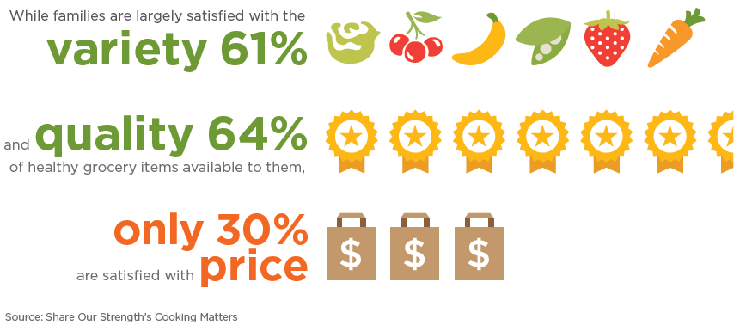

For the full report, generously supported by the ConAgra Foods® Foundation, visit **CookingMatters.org/Dinnertime**.

**GET INVOLVED**

Everyone has a strength, and everyone has something to share - chefs, culinary students, nutrition educators, companies, moms, dads and kids that care. Help us make No Kid Hungry a reality in America. Learn more at **CookingMatters.org**.

IN THEIR OWN WORDS

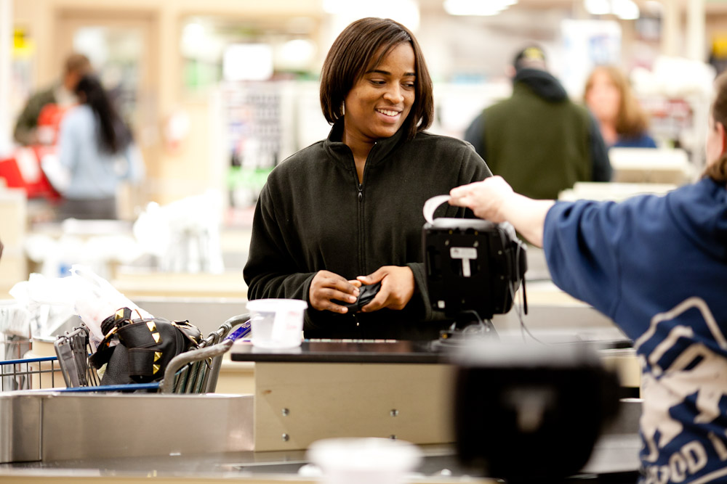

“Since the class, I can triple the amount of food I buy with my WIC check and feel good about what I’m feeding my kids.”

- Lareese Cathey, Cooking Matters graduate, Maryland

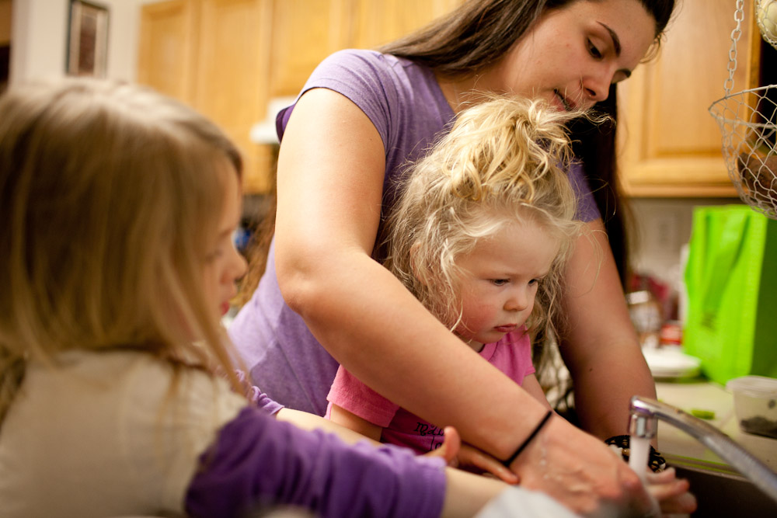

“I save anywhere between $100 and $150 a month after Cooking Matters. It makes a difference.”  
  
- Stacy Hanno, Cooking Matters graduate, Colorado

BY THE NUMBERS

* **38,000**: Six-week course participants in 2016
* **74,000**: Grocery store tour participants in 2016
* **464,000:** Families taught how to purchase and prepare healthy food since Cooking Matters started in 1993